EXPERIMENT 20
Implement the Dilation Technique as a Morphological Operation Using OpenCV
Aim:
To perform the Dilation morphological operation to expand the foreground regions of an image using OpenCV.
Procedure:
- Import OpenCV and NumPy libraries.
- Read the input image.
- Convert the image into grayscale.
- Create a kernel using np.ones().
- Apply dilation using cv2.dilate().
- Display the original and dilated images.
Program:
import cv2
import numpy as np

img = cv2.imread('image.jpg', 0)

kernel = np.ones((5,5), np.uint8)

dilation = cv2.dilate(img, kernel, iterations=1)

cv2.imshow('Original Image', img)
cv2.imshow('Dilation Image', dilation)

cv2.waitKey(0)
cv2.destroyAllWindows()
Input:

Output:
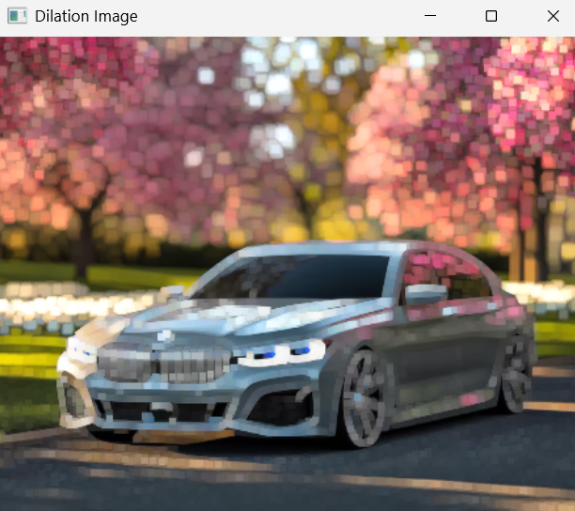
Result:
Thus, the Dilation morphological operation was successfully performed, expanding the foreground regions of the image.

